Create a React Application “eventexamplesapp” to handle various events of the form elements in HTML.

1. Create “Increment” button to increase the value of the counter and “Decrement” button to decrease the value of the counter. The “Increase” button should invoke multiple methods.

**App.jsx:**

import { useState } from 'react'

import './App.css'

function CurrencyConvertor() {

  const [amount, setAmount] = useState('');

  const [currency, setCurrency] = useState('');

  const handleSubmit = (e) => {

    e.preventDefault();

    if (currency.toLowerCase() === 'euro') {

      const converted = parseFloat(amount) * 80;

      alert(`Converting to ${currency} Amount is ${converted}`);

    } else {

      alert('Currency not supported');

    }

  };

  return (

    <>

      <h2 style={{ color: 'green' }}>Currency Convertor!!!</h2>

      <form onSubmit={handleSubmit}>

        <label>

          Amount: &nbsp;

          <input

            type="text"

            value={amount}

            onChange={(e) => setAmount(e.target.value)}

          />

        </label>

        <br /><br />

        <label>

          Currency: &nbsp;

          <textarea

            value={currency}

            onChange={(e) => setCurrency(e.target.value)}

          />

        </label>

        <br /><br />

        <button type="submit">Submit</button>

      </form>

    </>

  );

}

function App() {

  const [count, setCount] = useState(0);

  const handleIncrement = () => {

    increment();

    sayHello();

  };

  const increment = () => {

    setCount(count + 1);

  };

  const sayHello = () => {

    alert('Hello! Member1');

  };

  const handleDecrement = () => {

    setCount(count - 1);

  };

  const sayWelcome = (msg) => {

    alert(msg);

  };

  const handleClick = (e) => {

    alert('I was clicked');

  };

  return (

    <div style={{ margin: '20px' }}>

      <p>{count}</p>

      <button onClick={handleIncrement}>Increment</button>&nbsp;

      <button onClick={handleDecrement}>Decrement</button><br /><br />

      <button onClick={() => sayWelcome('welcome')}>Say welcome</button><br /><br />

      <button onClick={handleClick}>Click on me</button><br /><br />

      <CurrencyConvertor />

    </div>

  );

}

export default App;

**App.css:**

body {

  font-family: Arial, sans-serif;

}

input, textarea, button {

  font-size: 1rem;

  padding: 5px;

  margin-top: 5px;

}

h2 {

  font-size: 2rem;

}

* 1. To increment the value
  2. Say Hello followed by a static message.

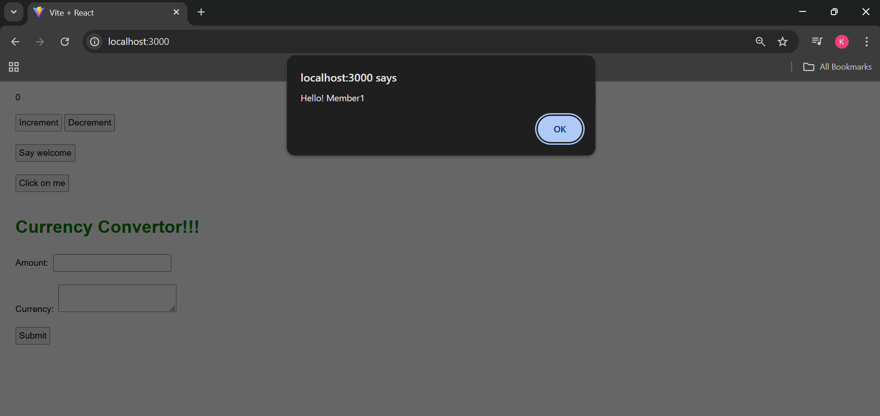

1. Create a button “Say Welcome” which invokes the function which takes “welcome” as an argument.

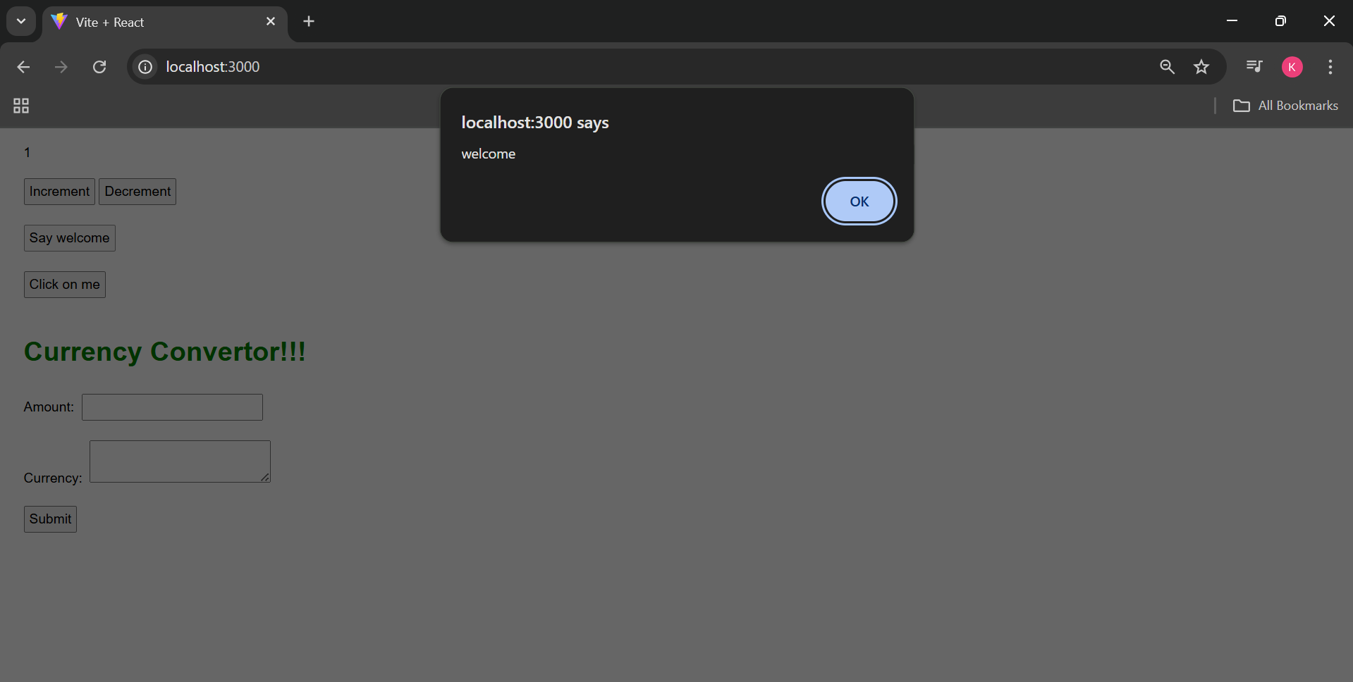

1. Create a button which invokes synthetic event “OnPress” which display “I was clicked”

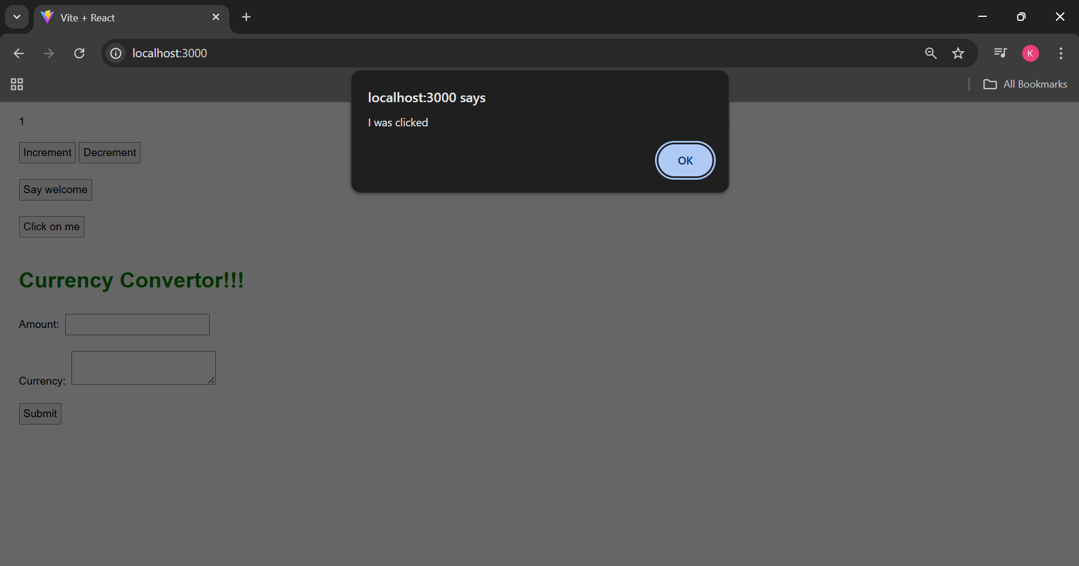

Create a “CurrencyConvertor” component which will convert the Indian Rupees to Euro when the Convert button is clicked.

Handle the Click event of the button to invoke the handleSubmit event and handle the conversion of the euro to rupees.

